**Bug 01 (Crash):**

|  |  |  |  |
| --- | --- | --- | --- |
| **Title** | The page becomes unresponsive when clicking on the numbers of results. | | |
| **Name of QA:** | Muhammad Hamas Khalid | | |
| **Severity** | **Issue Type** | **Frequency** | **Environment** |
| High | Crash | Every Time | All Browsers |
| **Step to reproduce:**   1. Open [**https://academybugs.com**](https://academybugs.com/) 2. Click the Find Bugs link on the navigation bar. 3. Click on the buttons to show a certain number of results at the top left | | | |
| **Expected Result:** | The selected number of results is displayed according to the clicked buttons | | |
| **Actual result** | The page freezes when clicking on the numbers of results | | |

**Attachments:**

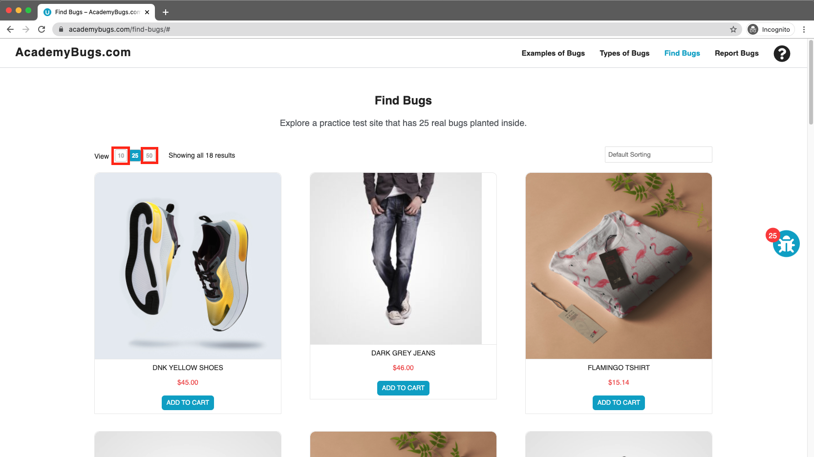

**Bug 02 (Functional):**

|  |  |  |  |
| --- | --- | --- | --- |
| **Title** | The product quantity cannot be increased past 2. | | |
| **Name of QA:** | Muhammad Hamas Khalid | | |
| **Severity** | **Issue Type** | **Frequency** | **Environment** |
| High | Functional | Every Time | All Browsers |
| **Step to reproduce:**   1. Open [**https://academybugs.com**](https://academybugs.com/) 2. Click the Find Bugs link on the navigation bar 3. Add one or more products to the cart 4. Click the "View cart" link on top of the page 5. Set the products quantity to 3 or more | | | |
| **Expected Result:** | The product quantity can be increased past 2 | | |
| **Actual result** | When clicking on the update button the product quantity becomes 2 again | | |

**Attachments:**

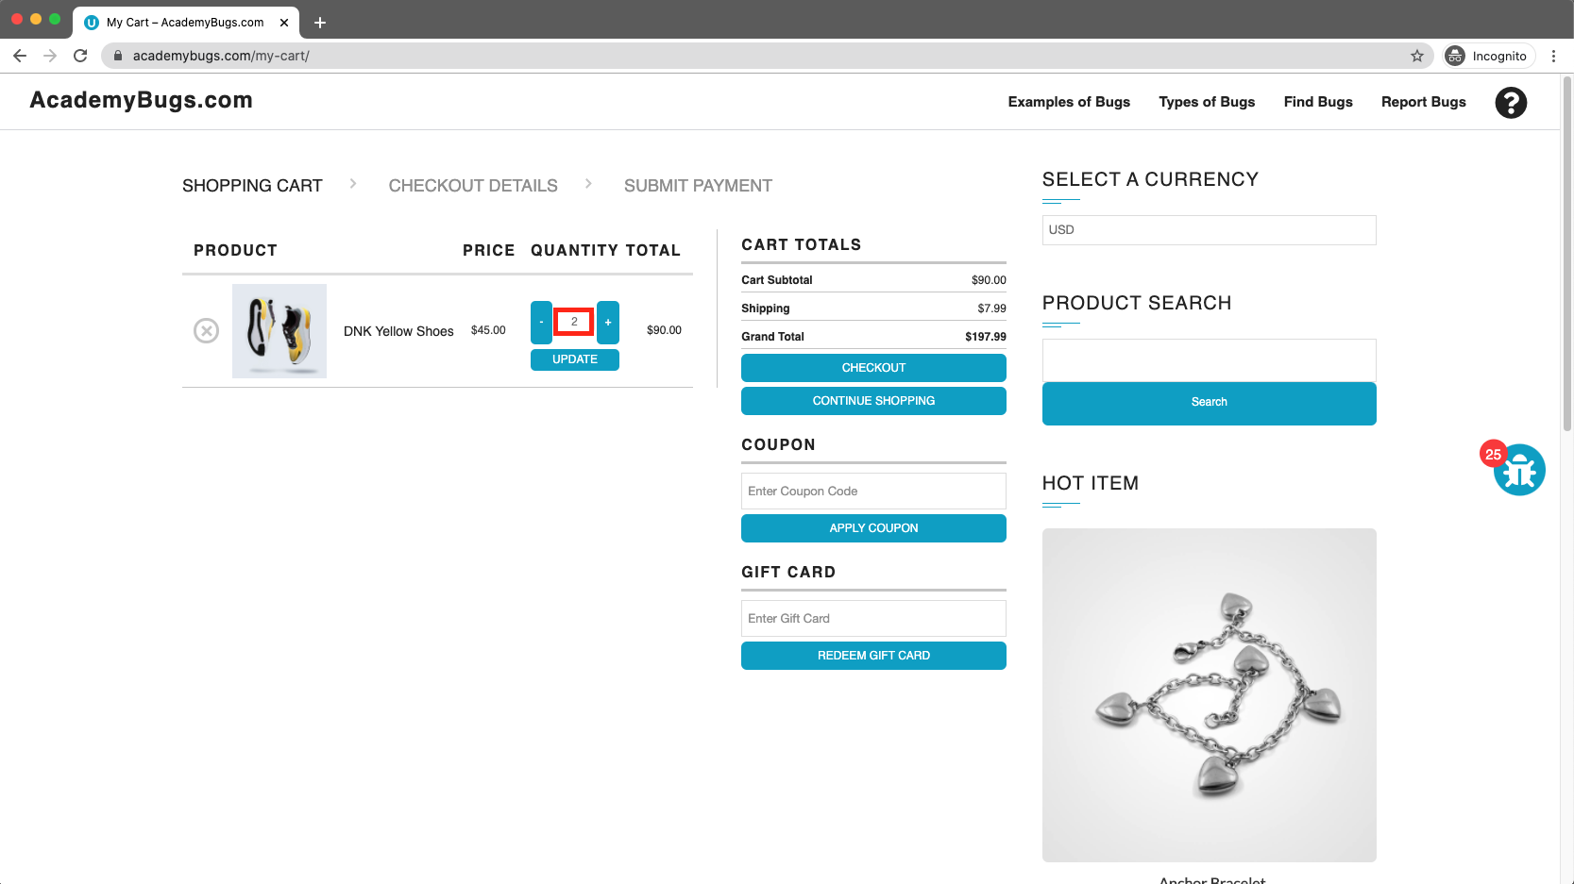

**Bug 03 (Content):**

|  |  |  |  |
| --- | --- | --- | --- |
| **Title** | There is big space before the last letter in "Return to Store". | | |
| **Name of QA:** | Muhammad Hamas Khalid | | |
| **Severity** | **Issue Type** | **Frequency** | **Environment** |
| Low | Content | Every Time | All Browsers |
| **Step to reproduce:**   1. Open [**https://academybugs.com**](https://academybugs.com/) 2. Click the Find Bugs link on the navigation bar 3. Open a product 4. Open the cart at the bottom of right side menu 5. Clear the cart if there are any items | | | |
| **Expected Result:** | The caption of the "Return to Store" button is written with even spacing between letters | | |
| **Actual result** | There is too much space before the last letter in "Return to Store" | | |

**Attachments:**

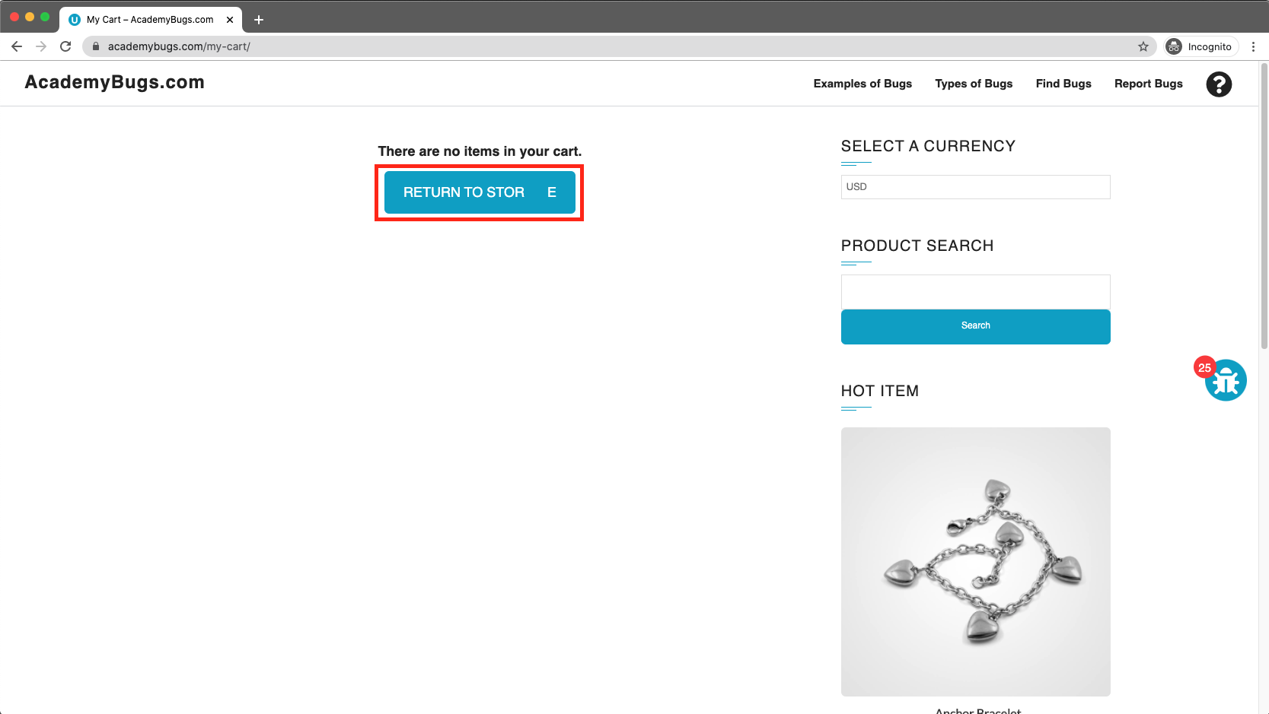

**Bug 04 (Crash):**

|  |  |  |  |
| --- | --- | --- | --- |
| **Title** | The page freezes when changing the currency. | | |
| **Name of QA:** | Muhammad Hamas Khalid | | |
| **Severity** | **Issue Type** | **Frequency** | **Environment** |
| High | Crash | Every Time | All Browsers |
| **Step to reproduce:**   1. Open [**https://academybugs.com**](https://academybugs.com/) 2. Click the Find Bugs link on the navigation bar 3. Open a product 4. Change the currency in the right side menu | | | |
| **Expected Result:** | The currency is changed as expected | | |
| **Actual result** | The page freezes when changing the currency | | |

**Attachments:**

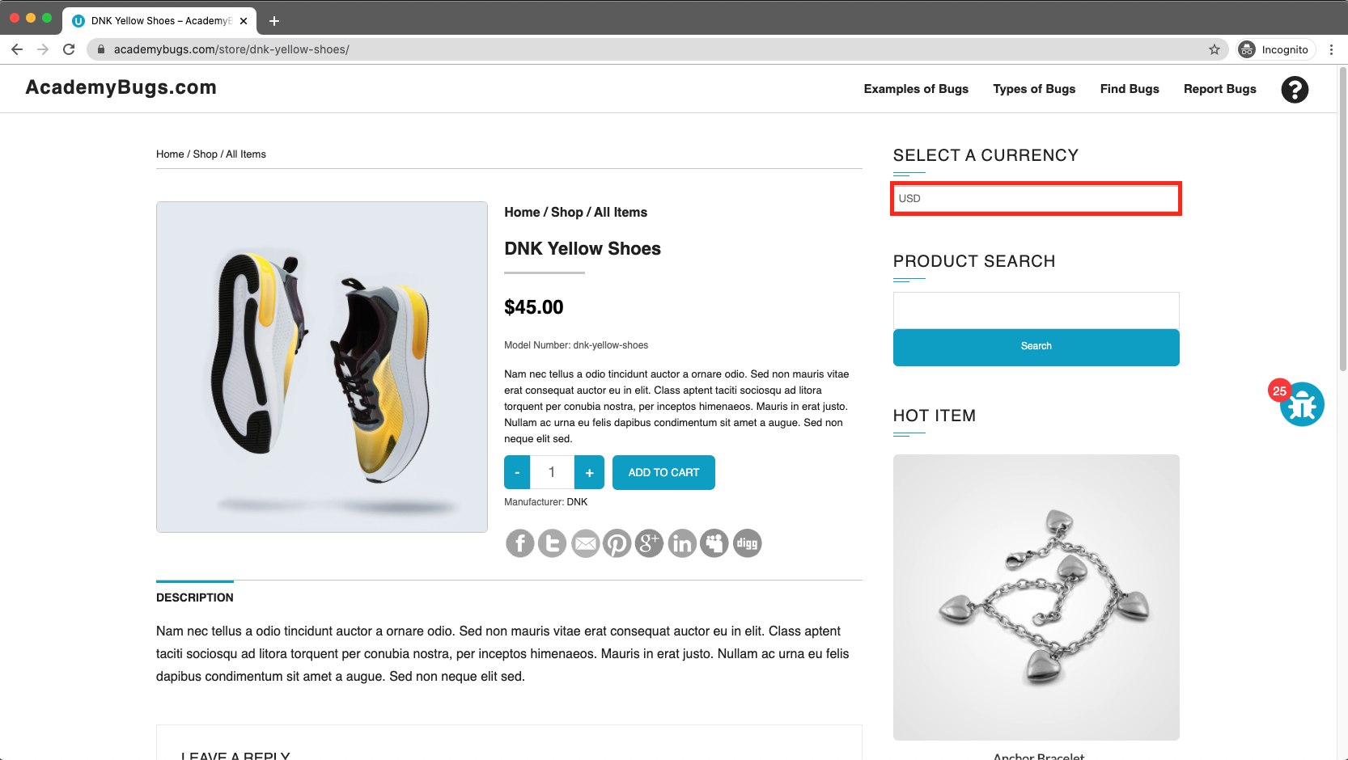

**Bug 05 (Visual):**

|  |  |  |  |
| --- | --- | --- | --- |
| **Title** | The Sign in button overlaps the folder. | | |
| **Name of QA:** | Muhammad Hamas Khalid | | |
| **Severity** | **Issue Type** | **Frequency** | **Environment** |
| Low | Visual | Every Time | All Browsers |
| **Step to reproduce:**   1. Open [**https://academybugs.com**](https://academybugs.com/) 2. Click the Find Bugs link on the navigation bar 3. Open a product 4. Scroll down to the bottom of the right side menu | | | |
| **Expected Result:** | The Sign In button is above the footer | | |
| **Actual result** | The Sign In button overlaps the footer | | |

**Attachments:**

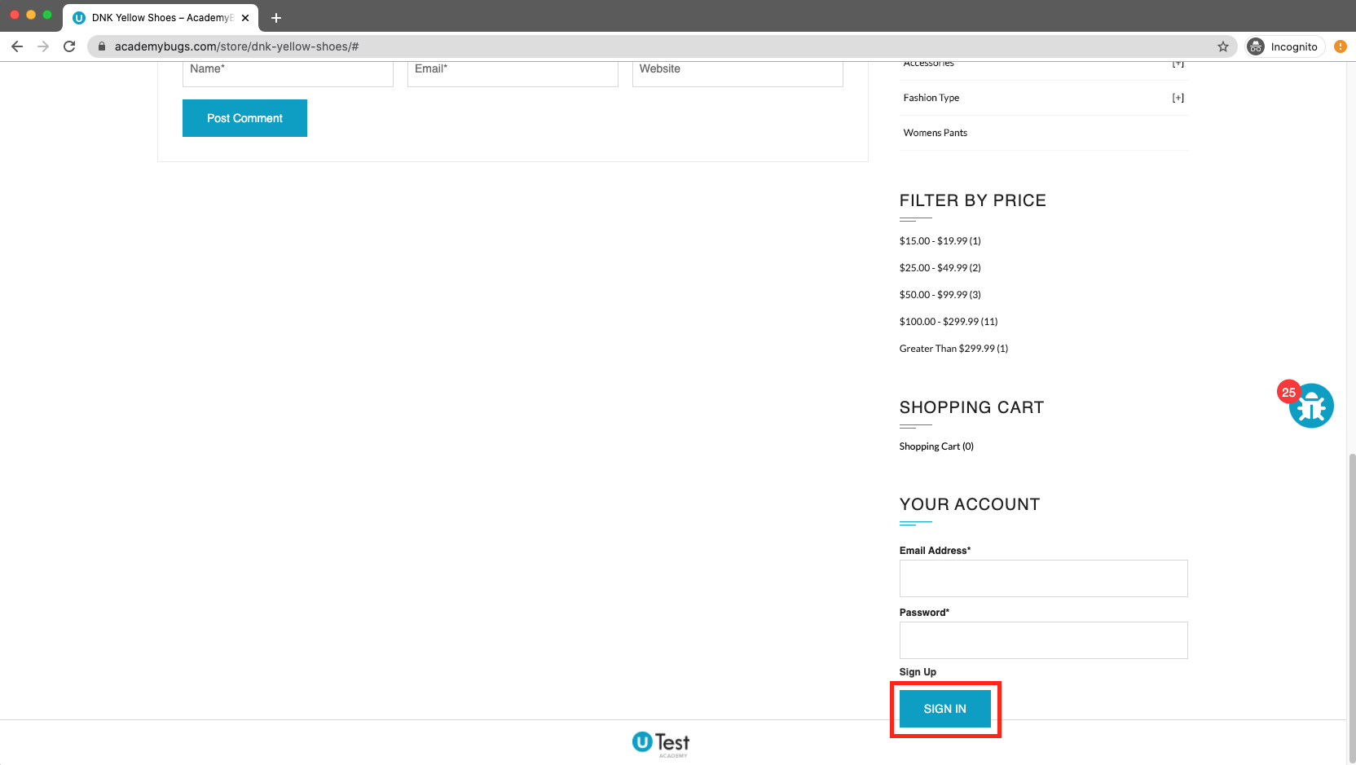

**Bug 06 (Performance):**

|  |  |  |  |
| --- | --- | --- | --- |
| **Title** | The billing address loads infinitely. | | |
| **Name of QA:** | Muhammad Hamas Khalid | | |
| **Severity** | **Issue Type** | **Frequency** | **Environment** |
| Medium | Performance | Every Time | All Browsers |
| **Step to reproduce:**   1. Open [**https://academybugs.com**](https://academybugs.com/) 2. Click the Find Bugs link on the navigation bar 3. Open a product 4. Sign up if you are not signed up or log in at the bottom of right side menu 5. At the bottom of the right side menu select Dashboard 6. Scroll up to the Billing Address section | | | |
| **Expected Result:** | The Billing Address section shows appropriate info | | |
| **Actual result** | The Billing Address section loads infinitely | | |

**Attachments:**

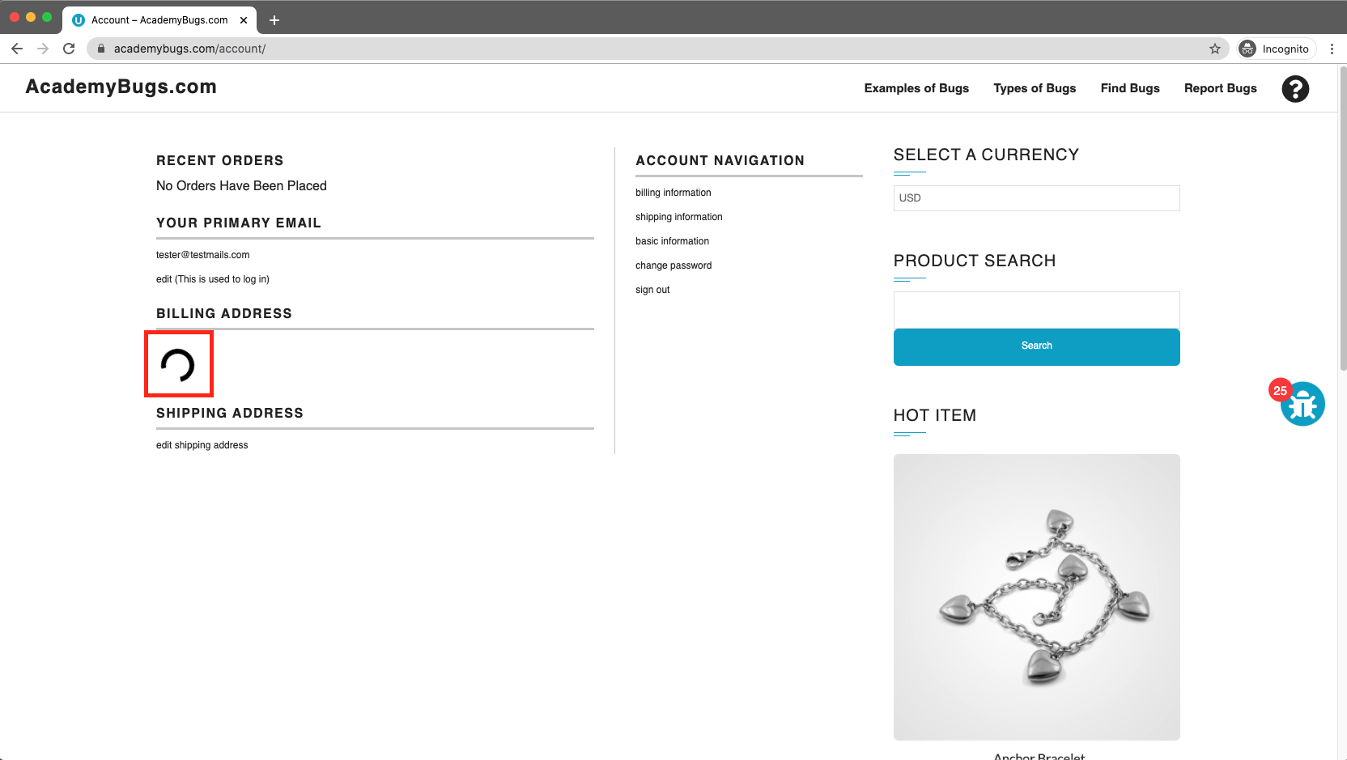

**Bug 07 (Visual):**

|  |  |  |  |
| --- | --- | --- | --- |
| **Title** | Item images have unnecessary space underneath. | | |
| **Name of QA:** | Muhammad Hamas Khalid | | |
| **Severity** | **Issue Type** | **Frequency** | **Environment** |
| Low | Visual | Every Time | All Browsers |
| **Step to reproduce:**   1. Open [**https://academybugs.com**](https://academybugs.com/) 2. Click the Find Bugs link on the navigation bar 3. Open a product 4. Find the Store Menu section in the right side menu 5. Choose All Items | | | |
| **Expected Result:** | Item images have no space underneath | | |
| **Actual result** | Item images have unnecessary space underneath | | |

**Attachments:**

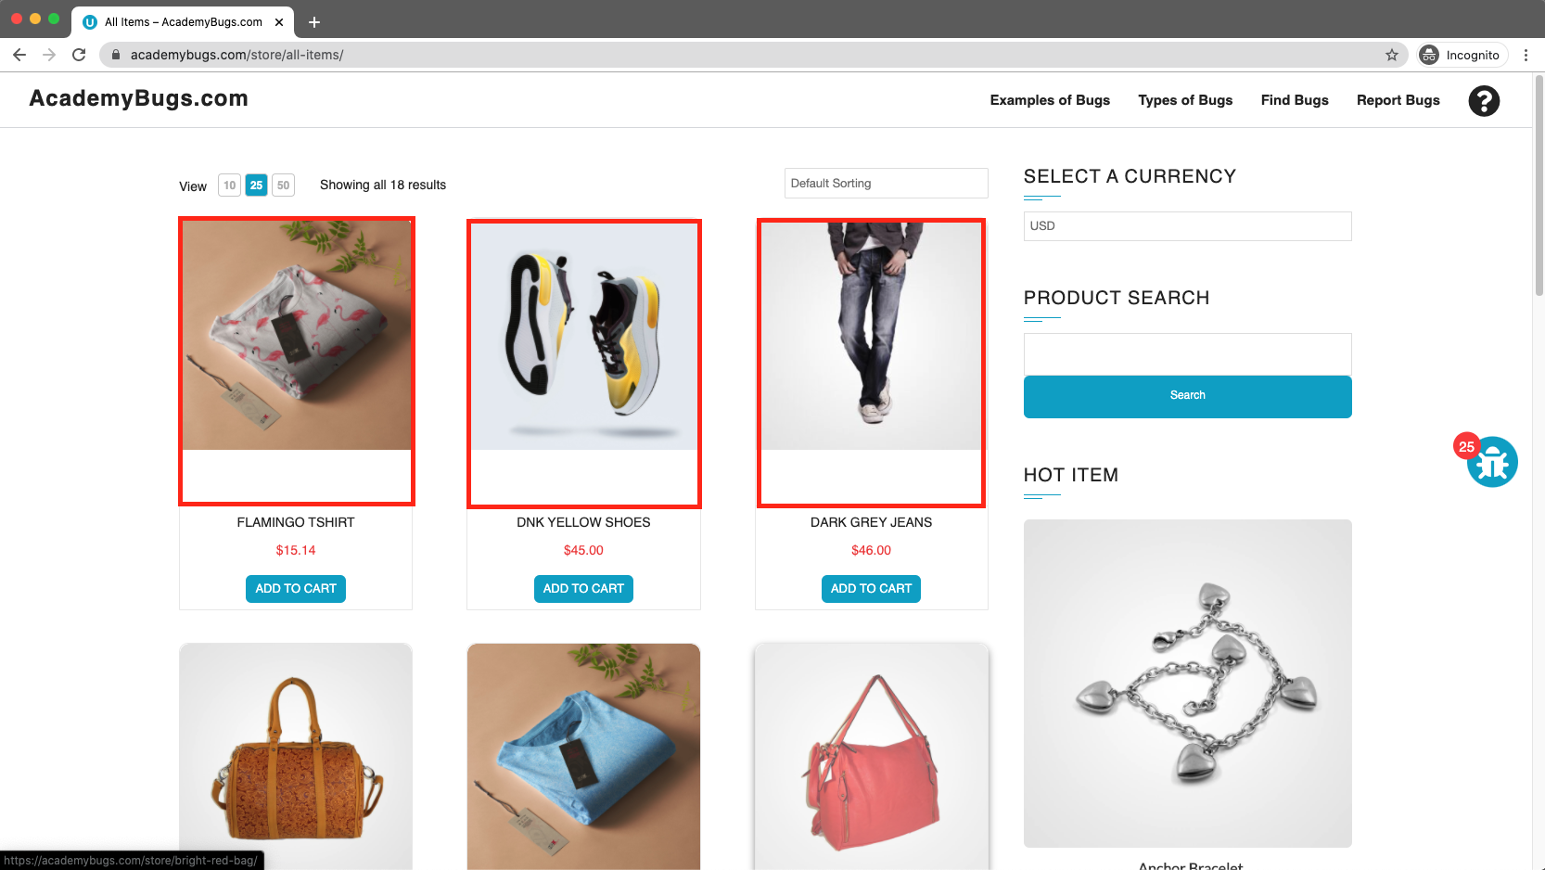

**Bug 08 (Content):**

|  |  |  |  |
| --- | --- | --- | --- |
| **Title** | The short description and description of the product are not in English. | | |
| **Name of QA:** | Muhammad Hamas Khalid | | |
| **Severity** | **Issue Type** | **Frequency** | **Environment** |
| Medium | Content | Every Time | All Browsers |
| **Step to reproduce:**   1. Open [**https://academybugs.com**](https://academybugs.com/) 2. Click the Find Bugs link on the navigation bar 3. Open a product | | | |
| **Expected Result:** | The short description and description of the product are in English | | |
| **Actual result** | The short description and description of the product are not in English | | |

**Attachments:**

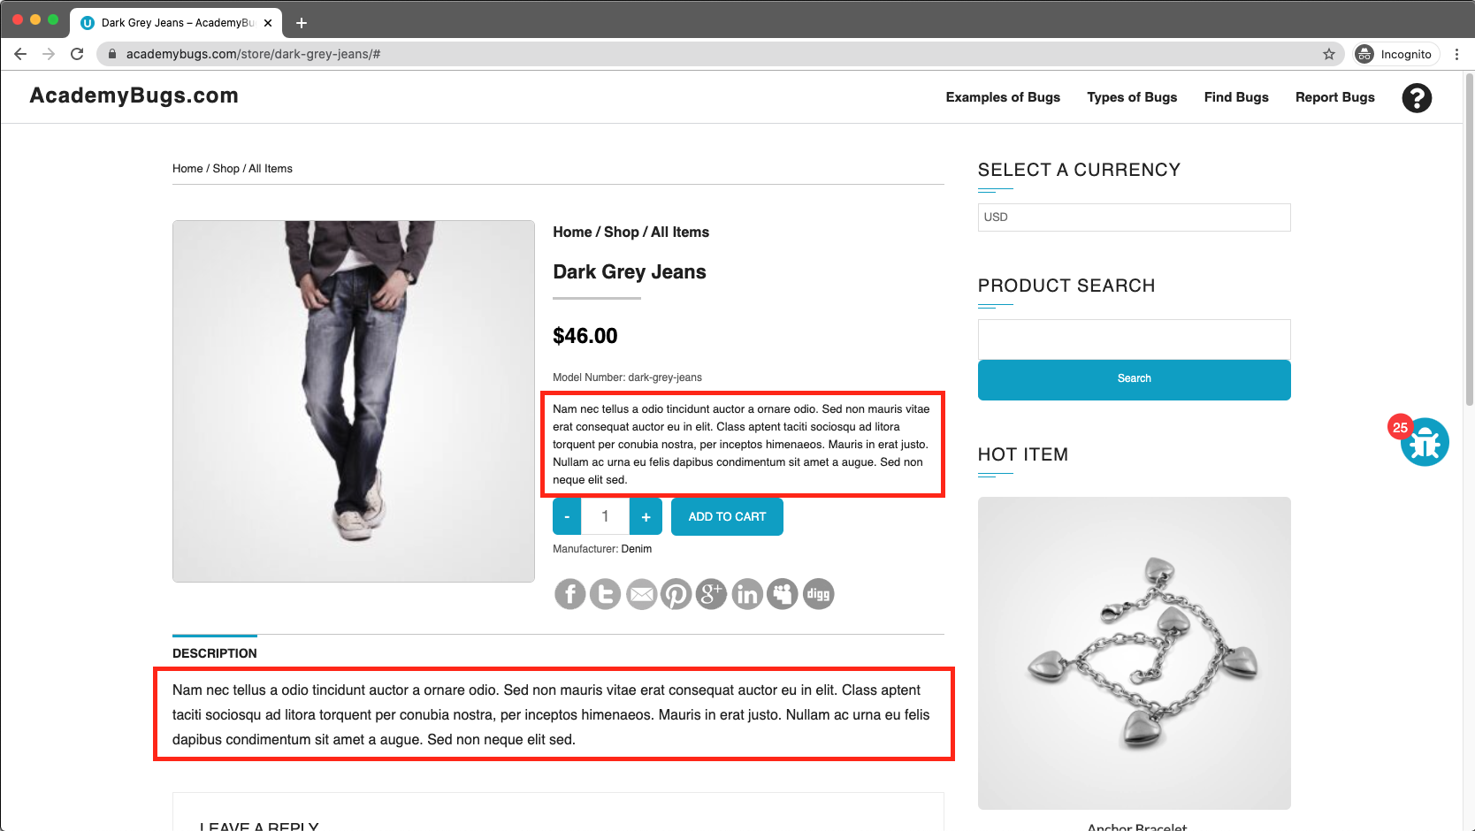

**Bug 09 (Crash):**

|  |  |  |  |
| --- | --- | --- | --- |
| **Title** | The page becomes unresponsive when clicking on the Post Comment button. | | |
| **Name of QA:** | Muhammad Hamas Khalid | | |
| **Severity** | **Issue Type** | **Frequency** | **Environment** |
| High | Crash | Every Time | All Browsers |
| **Step to reproduce:**   1. Open [**https://academybugs.com**](https://academybugs.com/) 2. Click the Find Bugs link on the navigation bar 3. Open a product 4. Scroll down to the Leave a Reply section 5. Fill out the comment form 6. Click "Post Comment" | | | |
| **Expected Result:** | The comment is posted under the product. | | |
| **Actual result** | The page becomes unresponsive when clicking on "Post Comment" | | |

**Attachments:**

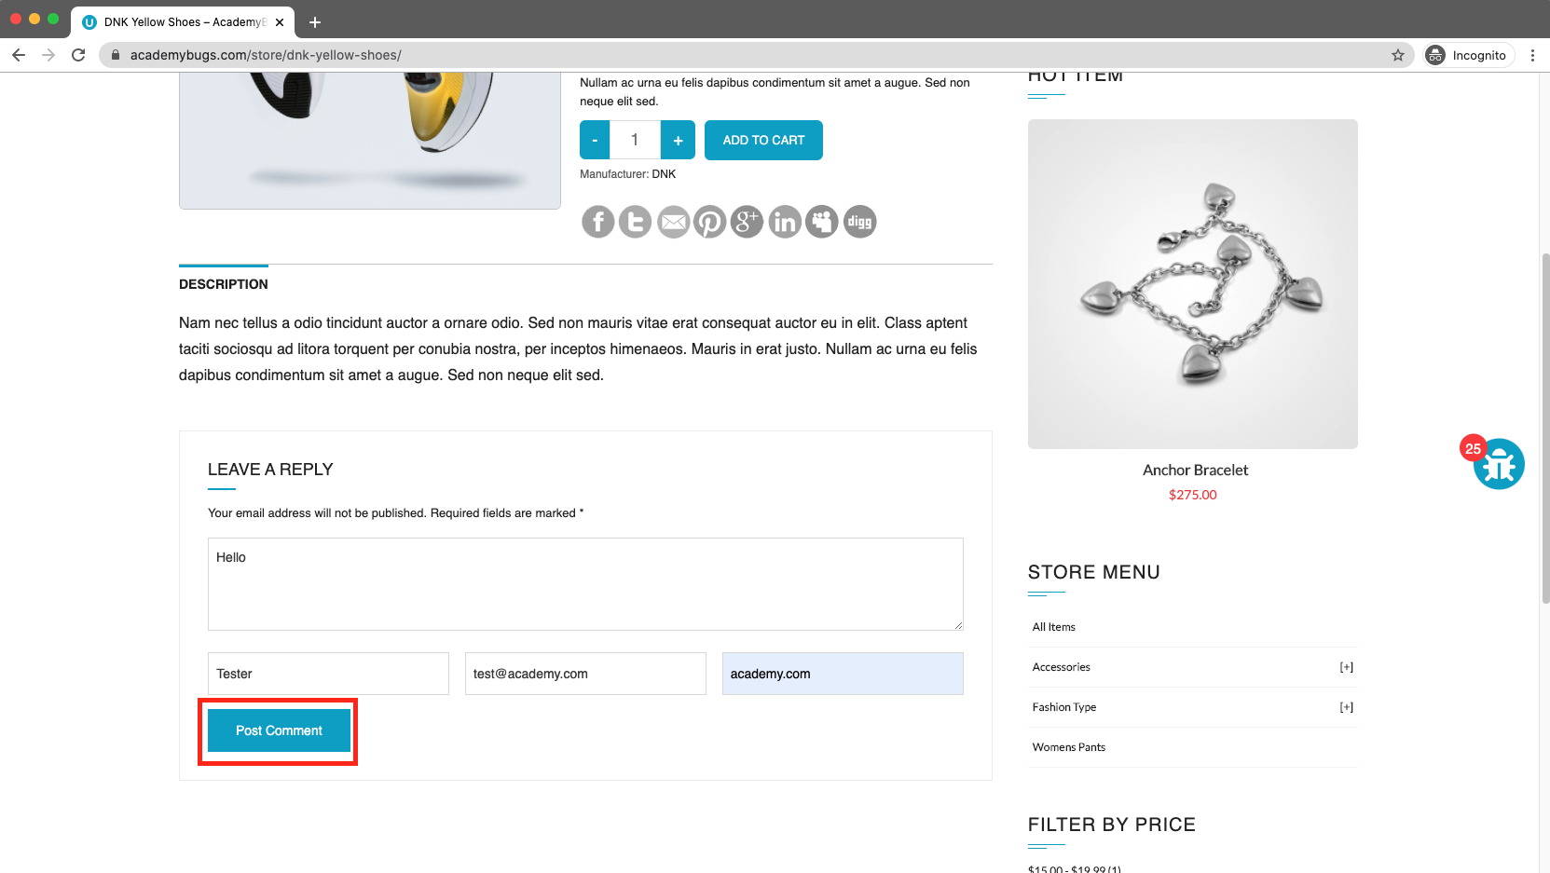

**Bug 10 (Functional):**

|  |  |  |  |
| --- | --- | --- | --- |
| **Title** | The filter by price doesn't work in the product details page. | | |
| **Name of QA:** | Muhammad Hamas Khalid | | |
| **Severity** | **Issue Type** | **Frequency** | **Environment** |
| Medium | Functional | Every Time | All Browsers |
| **Step to reproduce:**   1. Open [**https://academybugs.com**](https://academybugs.com/) 2. Click the Find Bugs link on the navigation bar 3. Open a product 4. On the right side menu find the Filter by Price section 5. Select any of the price ranges | | | |
| **Expected Result:** | A list of products in the selected price range is shown | | |
| **Actual result** | The same page reloads | | |

**Attachments:**

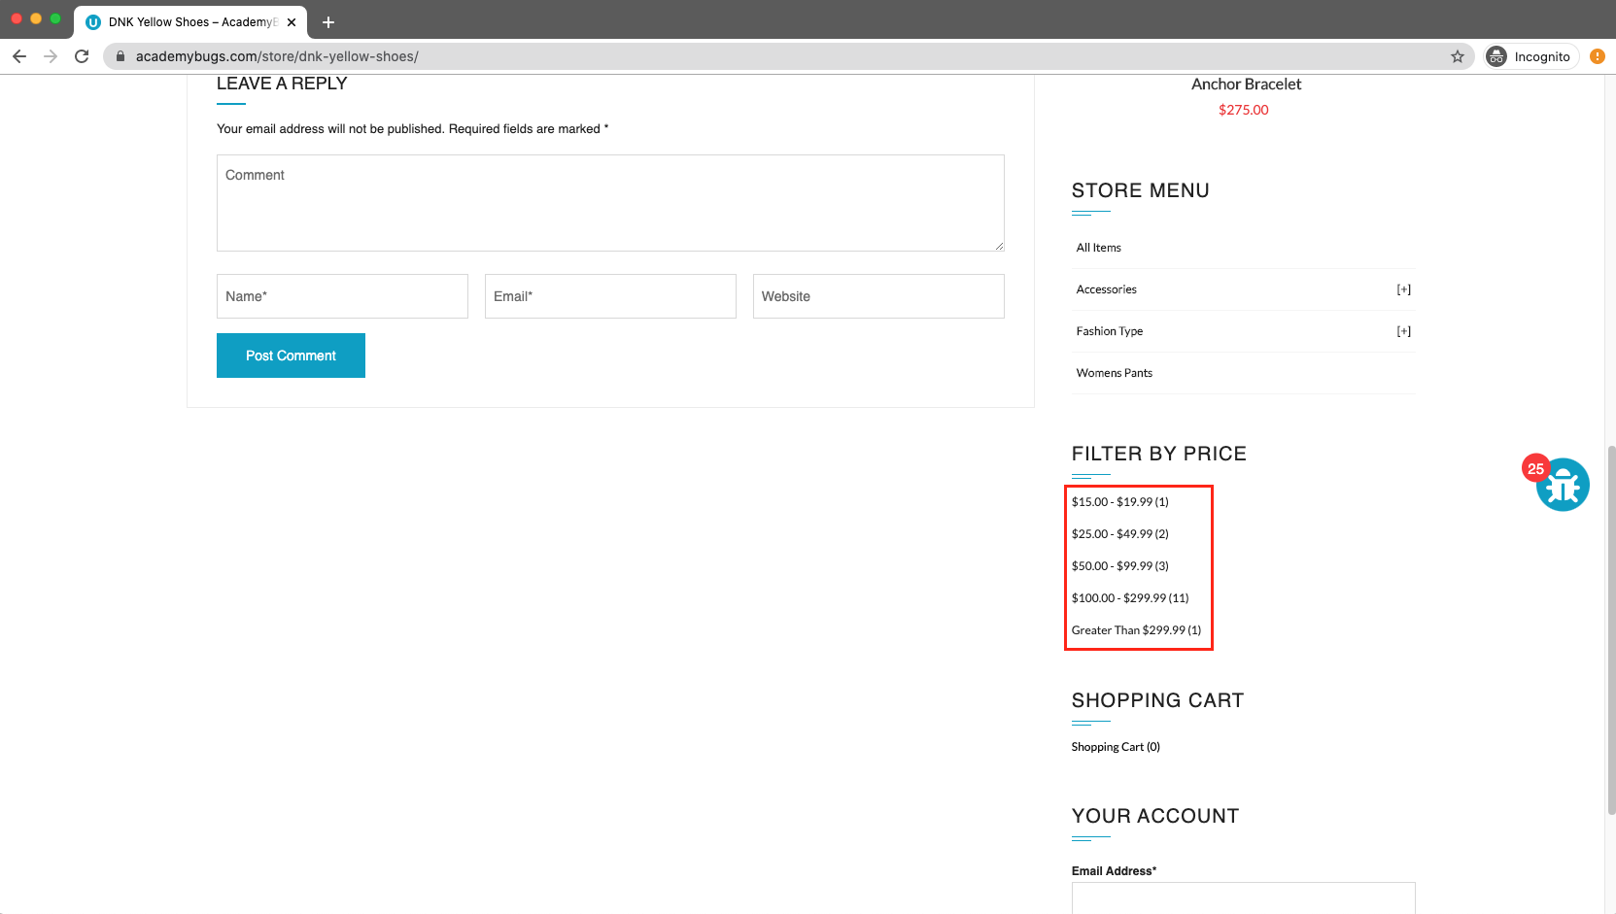

**Bug 11 (Functional):**

|  |  |  |  |
| --- | --- | --- | --- |
| **Title** | The grand total is $100 more than the sum of all products in the cart. | | |
| **Name of QA:** | Muhammad Hamas Khalid | | |
| **Severity** | **Issue Type** | **Frequency** | **Environment** |
| Critical | Functional | Every Time | All Browsers |
| **Step to reproduce:**   1. Open [**https://academybugs.com**](https://academybugs.com/) 2. Click the Find Bugs link on the navigation bar 3. Add one or more products to the cart 4. Click the "View cart" link on top of the page, or click "Continue to Shipping" in the checkout details page | | | |
| **Expected Result:** | The grand total is equal to the sum of all products in the cart | | |
| **Actual result** | The grand total is $100 more than the sum of all products in the cart | | |

**Attachments:**

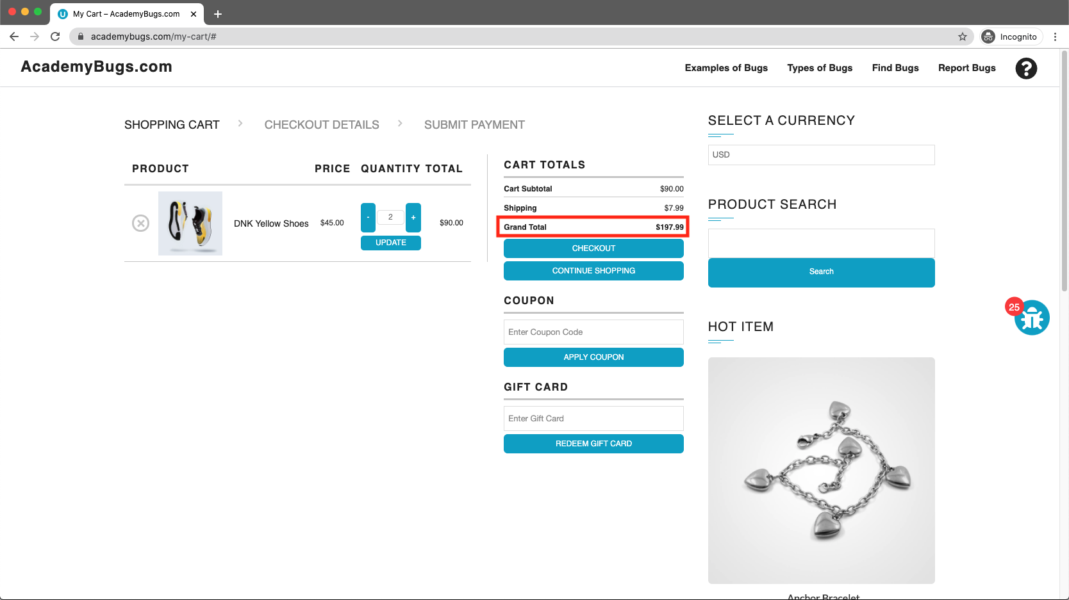

**Bug 12 (Content):**

|  |  |  |  |
| --- | --- | --- | --- |
| **Title** | There are unreadable symbols in the shopping cart popup. | | |
| **Name of QA:** | Muhammad Hamas Khalid | | |
| **Severity** | **Issue Type** | **Frequency** | **Environment** |
| Low | Content | Every Time | All Browsers |
| **Step to reproduce:**   1. Open [**https://academybugs.com**](https://academybugs.com/) 2. Click the Find Bugs link on the navigation bar 3. Add one or more products to the cart 4. Click "View Cart" on top of the page 5. Scroll down to the Shopping Cart section of the right side menu 6. Hover over the Shopping Cart caption | | | |
| **Expected Result:** | All characters are clear to a regular user | | |
| **Actual result** | There are unreadable symbols in the shopping cart popup | | |

**Attachments:**

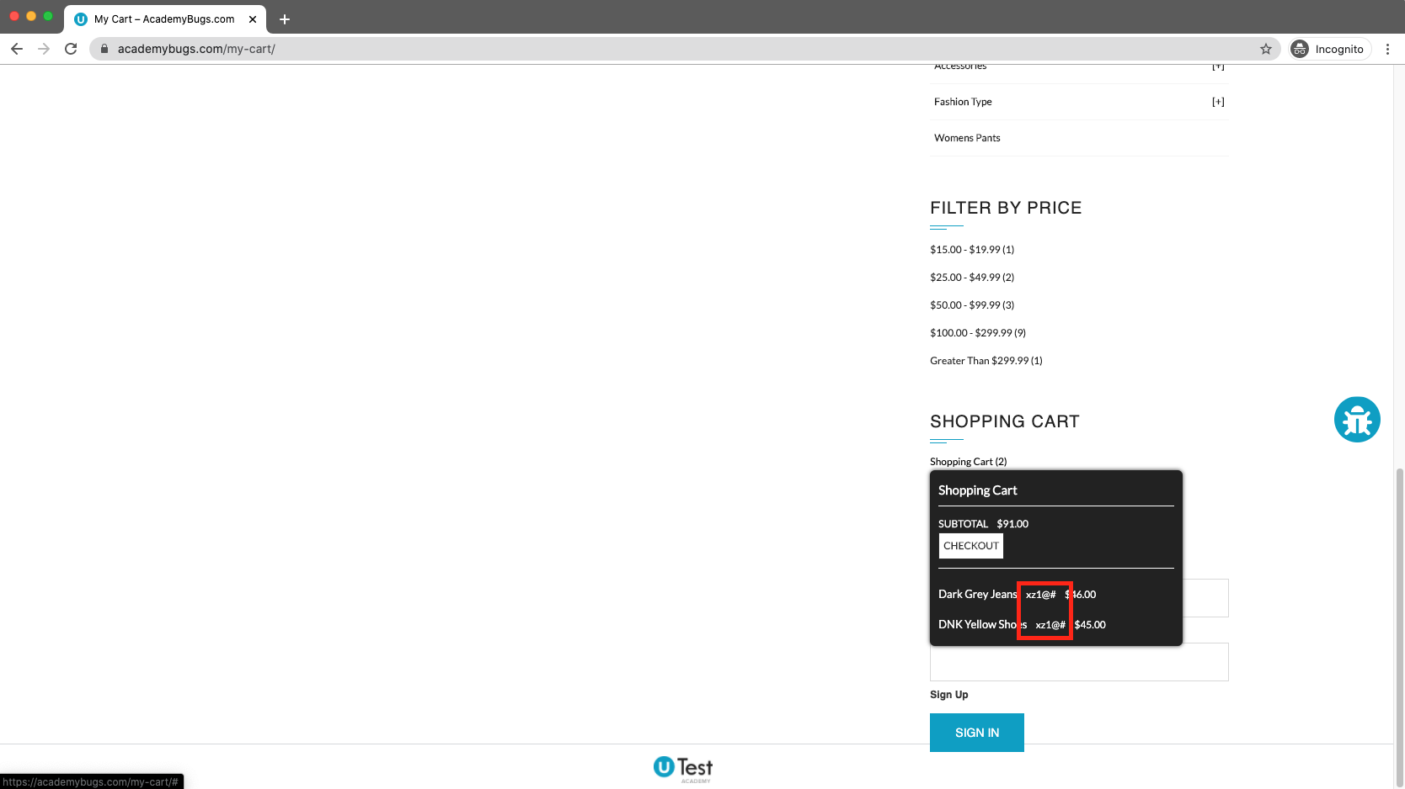

**Bug 13 (Functional):**

|  |  |  |  |
| --- | --- | --- | --- |
| **Title** | The manufacturer link in the product details page is broken. | | |
| **Name of QA:** | Muhammad Hamas Khalid | | |
| **Severity** | **Issue Type** | **Frequency** | **Environment** |
| Medium | Functional | Every Time | All Browsers |
| **Step to reproduce:**   1. Open [**https://academybugs.com**](https://academybugs.com/) 2. Click the Find Bugs link on the navigation bar 3. Open a product 4. Click the manufacturer link under the quantity | | | |
| **Expected Result:** | The manufacturer link shows an appropriate page | | |
| **Actual result** | The manufacturer link opens an error page | | |

**Attachments:**

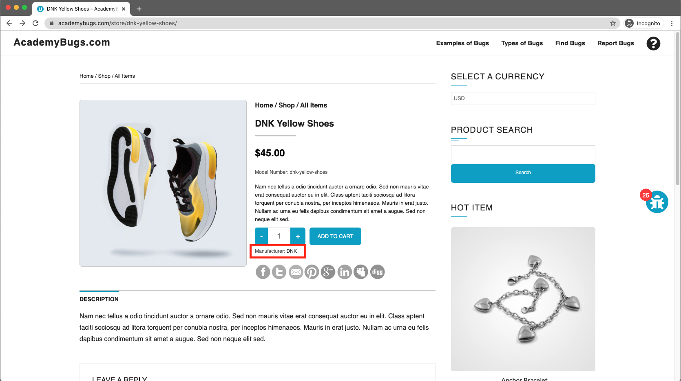

**Bug 14 (Content):**

|  |  |  |  |
| --- | --- | --- | --- |
| **Title** | The yellow and orange colors of the product are misspelled. | | |
| **Name of QA:** | Muhammad Hamas Khalid | | |
| **Severity** | **Issue Type** | **Frequency** | **Environment** |
| Low | Content | Every Time | All Browsers |
| **Step to reproduce:**   1. Open [**https://academybugs.com**](https://academybugs.com/) 2. Click the Find Bugs link on the navigation bar 3. Open a product with color options 4. Choose the Yellow and Orange colors | | | |
| **Expected Result:** | The yellow and orange colors are spelled correctly | | |
| **Actual result** | Yellow is misspelled as "Yelow" and Orange as "Orang" | | |

**Attachments:**

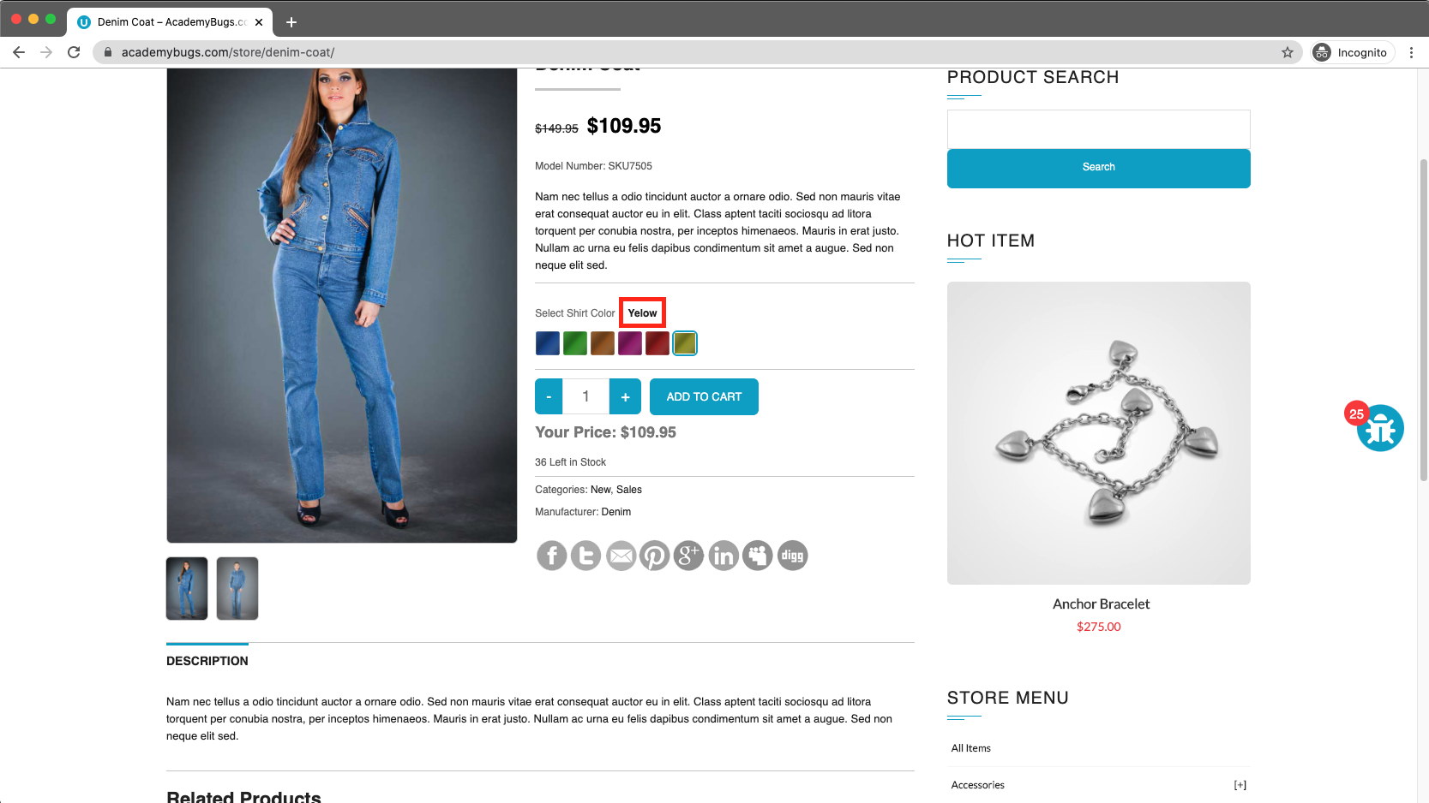

**Bug 15 (Functional):**

|  |  |  |  |
| --- | --- | --- | --- |
| **Title** | The twitter share button in the product details page is broken. | | |
| **Name of QA:** | Muhammad Hamas Khalid | | |
| **Severity** | **Issue Type** | **Frequency** | **Environment** |
| Medium | Functional | Every Time | All Browsers |
| **Step to reproduce:**   1. Open [**https://academybugs.com**](https://academybugs.com/) 2. Click the Find Bugs link on the navigation bar 3. Open a product 4. Click the twitter share button | | | |
| **Expected Result:** | The twitter share button shows an appropriate page | | |
| **Actual result** | The twitter share button shows an error page | | |

**Attachments:**

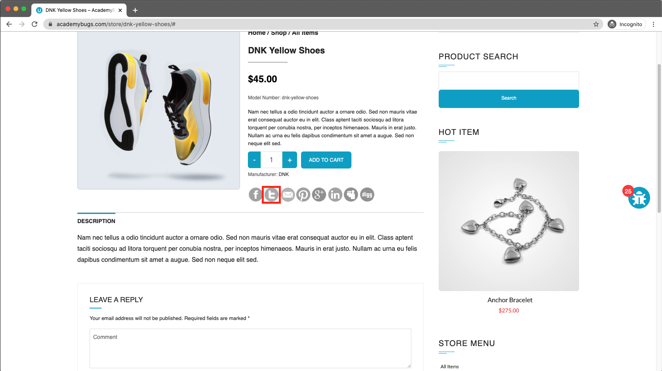

**Bug 16 (Performance):**

|  |  |  |  |
| --- | --- | --- | --- |
| **Title** | The product in the Hot Item section keeps loading. | | |
| **Name of QA:** | Muhammad Hamas Khalid | | |
| **Severity** | **Issue Type** | **Frequency** | **Environment** |
| High | Performance | Every Time | All Browsers |
| **Step to reproduce:**   1. Open [**https://academybugs.com**](https://academybugs.com/) 2. Click the Find Bugs link on the navigation bar 3. Open a product 4. Open the product in the Hot Item section of the right side menu | | | |
| **Expected Result:** | The product in the Hot Item section is displayed | | |
| **Actual result** | The page loads infinitely | | |

**Attachments:**

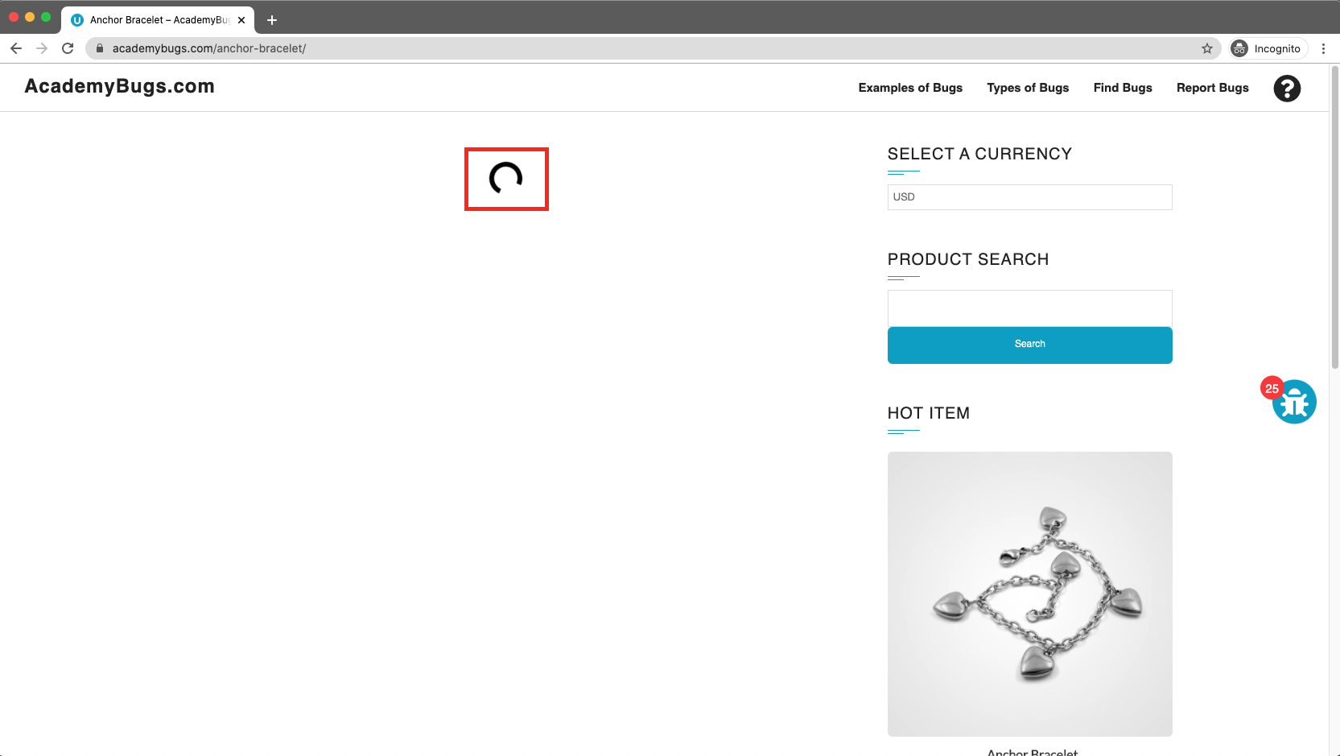

**Bug 17 (Crash):**

|  |  |  |  |
| --- | --- | --- | --- |
| **Title** | The page becomes unresponsive when clicking on the Retrieve Password button. | | |
| **Name of QA:** | Muhammad Hamas Khalid | | |
| **Severity** | **Issue Type** | **Frequency** | **Environment** |
| High | Crash | Every Time | All Browsers |
| **Step to reproduce:**   1. Open [**https://academybugs.com**](https://academybugs.com/) 2. Click the Find Bugs link on the navigation bar 3. Open a product 4. Scroll down to the Your Account section of the right side menu 5. Click "Sign Up" 6. In the Returning Customer section click "Forgot Your Password?" 7. Enter your email in the field and click "Retrieve Password | | | |
| **Expected Result:** | The password is sent to the entered email | | |
| **Actual result** | The page becomes unresponsive when clicking on "Retrieve Password" and no email is sent | | |

**Attachments:**

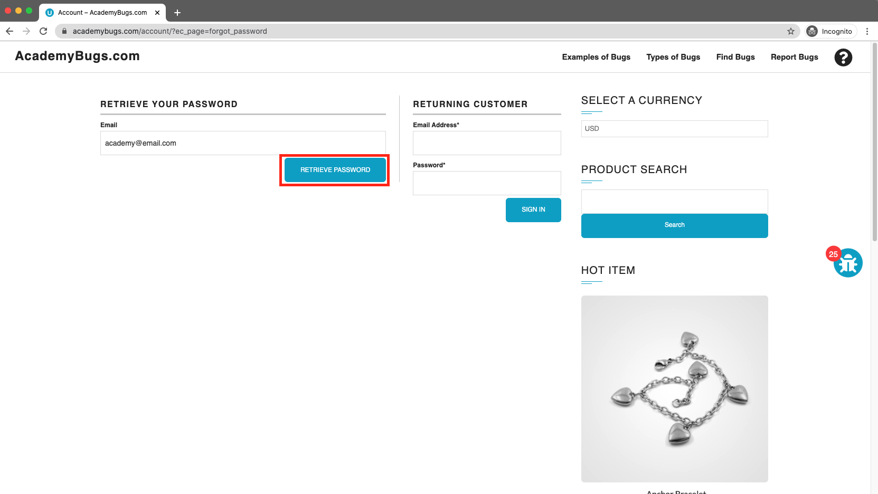

**Bug 18 (Performance):**

|  |  |  |  |
| --- | --- | --- | --- |
| **Title** | The order history loads infinitely. | | |
| **Name of QA:** | Muhammad Hamas Khalid | | |
| **Severity** | **Issue Type** | **Frequency** | **Environment** |
| High | Performance | Every Time | All Browsers |
| **Step to reproduce:**   1. Open [**https://academybugs.com**](https://academybugs.com/) 2. Click the Find Bugs link on the navigation bar 3. Open a product 4. Sign up if you are not signed up or log in at the bottom of right side menu 5. At the bottom of the right side menu select Order History | | | |
| **Expected Result:** | Your Order History section shows appropriate info | | |
| **Actual result** | Your Order History section loads infinitely | | |

**Attachments:**

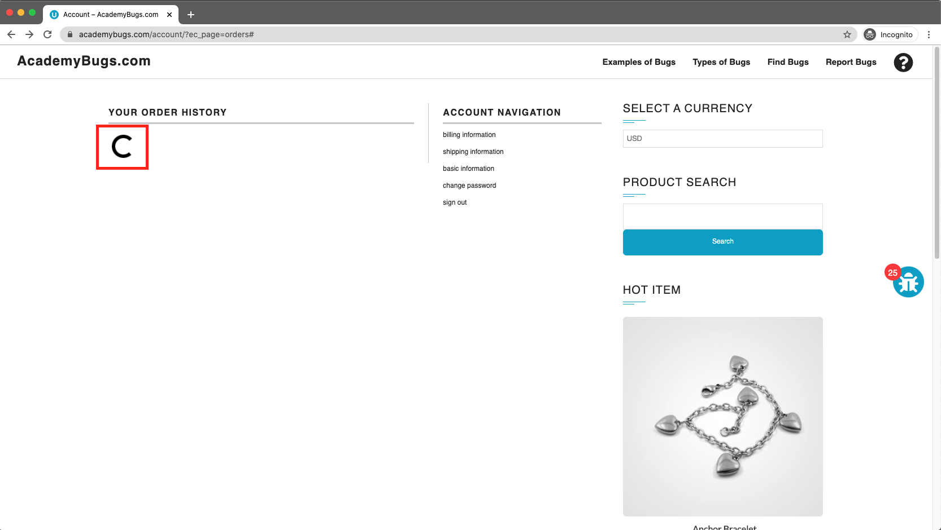

**Bug 19 (Performance):**

|  |  |  |  |
| --- | --- | --- | --- |
| **Title** | The billing information isn't updated | | |
| **Name of QA:** | Muhammad Hamas Khalid | | |
| **Severity** | **Issue Type** | **Frequency** | **Environment** |
| High | Performance | Every Time | All Browsers |
| **Step to reproduce:**   1. Open [**https://academybugs.com**](https://academybugs.com/) 2. Click the Find Bugs link on the navigation bar 3. Open a product 4. Click "Sign Up" at the bottom of right side menu 5. Sign up with fake data if you are not signed up. Otherwise enter your credentials and log in 6. At the bottom of the right side menu select Billing Information 7. Fill out the billing information form 8. Click "Update" | | | |
| **Expected Result:** | Billing information is updated after filling out the form and clicking "Update" | | |
| **Actual result** | Billing information loads infinitely after filling out the form and clicking "Update" | | |

**Attachments:**

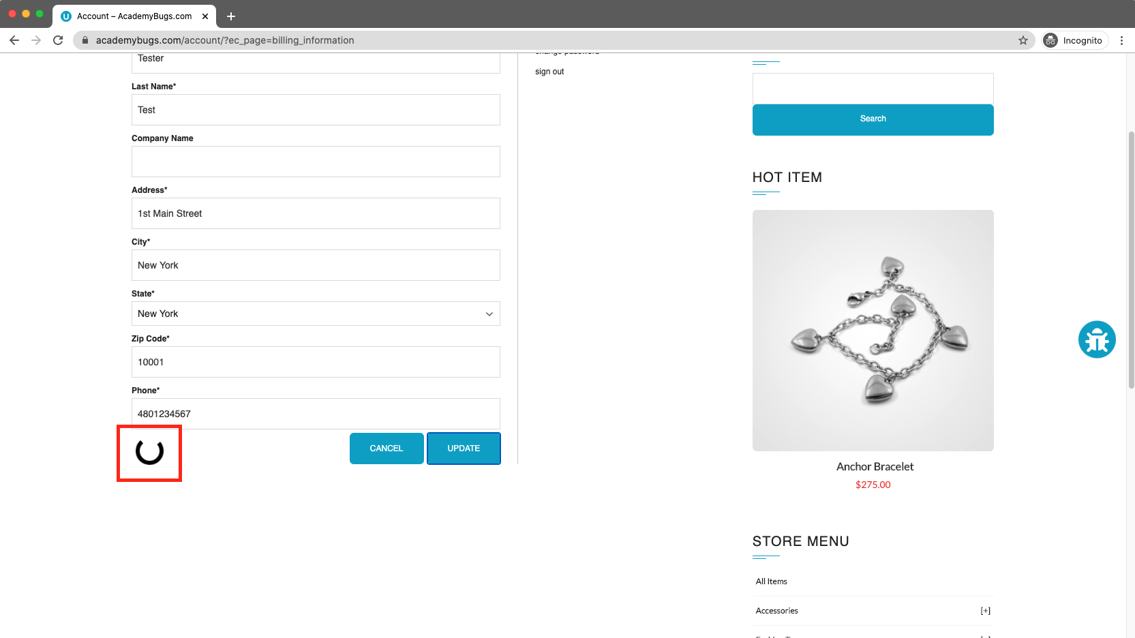

**Bug 20 (Visual):**

|  |  |  |  |
| --- | --- | --- | --- |
| **Title** | The caption of the Sign In button is misaligned vertically. | | |
| **Name of QA:** | Muhammad Hamas Khalid | | |
| **Severity** | **Issue Type** | **Frequency** | **Environment** |
| Low | Visual | Every Time | All Browsers |
| **Step to reproduce:**   1. Open [**https://academybugs.com**](https://academybugs.com/) 2. Click the Find Bugs link on the navigation bar 3. Open a product 4. Scroll to the bottom and find the sign in form in the right side menu 5. Enter any login and password that are not registered and click "Sign In" | | | |
| **Expected Result:** | The caption of the Sign In button is centered vertically | | |
| **Actual result** | The caption of the Sign In button is misaligned vertically | | |

**Attachments:**

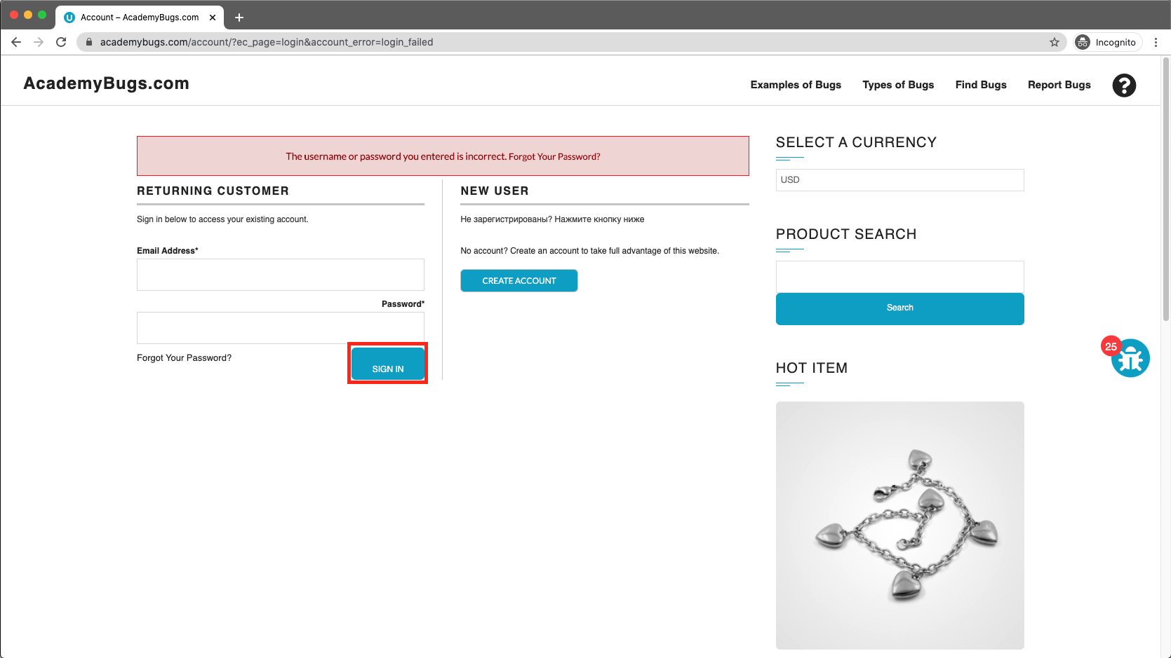

**Bug 21 (Content):**

|  |  |  |  |
| --- | --- | --- | --- |
| **Title** | The text under the New User section is not in English. | | |
| **Name of QA:** | Muhammad Hamas Khalid | | |
| **Severity** | **Issue Type** | **Frequency** | **Environment** |
| Low | Content | Every Time | All Browsers |
| **Step to reproduce:**   1. Open [**https://academybugs.com**](https://academybugs.com/) 2. Click the Find Bugs link on the navigation bar 3. Open a product 4. Scroll down to the bottom of the right side menu 5. Click "Sign In" to open the sign in page | | | |
| **Expected Result:** | The text under the New User section is in English | | |
| **Actual result** | The text under the New User section is in another language | | |

**Attachments:**

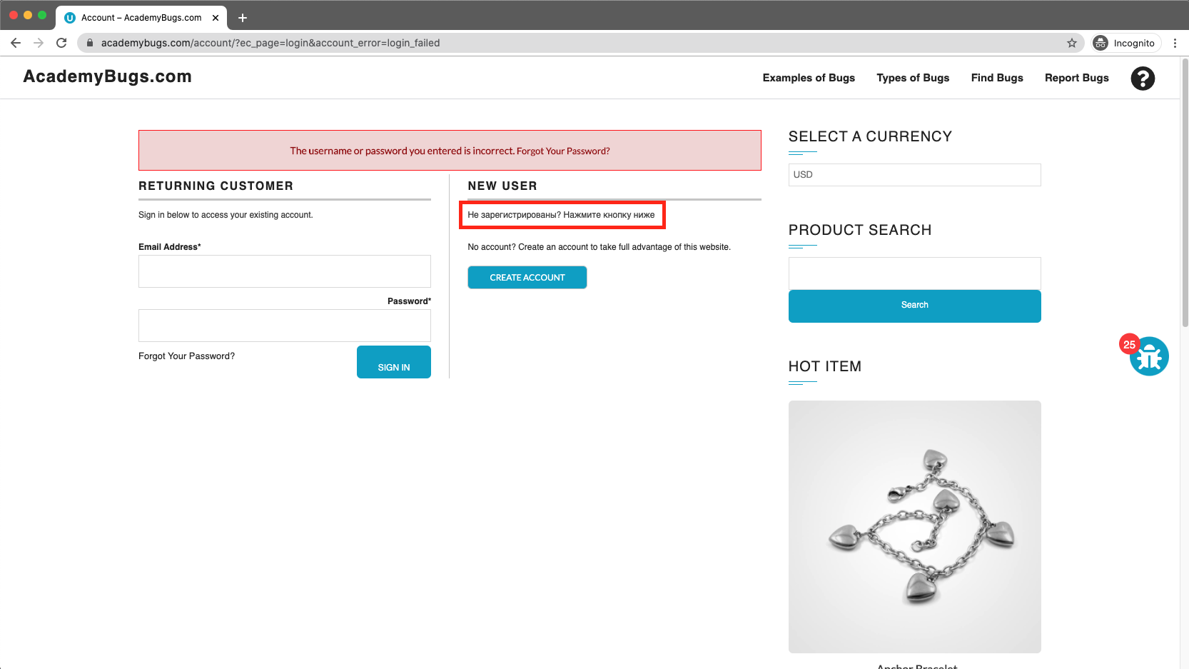

**Bug 22 (Visual):**

|  |  |  |  |
| --- | --- | --- | --- |
| **Title** | The title of the password field is misaligned. | | |
| **Name of QA:** | Muhammad Hamas Khalid | | |
| **Severity** | **Issue Type** | **Frequency** | **Environment** |
| Low | Visual | Every Time | All Browsers |
| **Step to reproduce:**   1. Open [**https://academybugs.com**](https://academybugs.com/) 2. Click the Find Bugs link on the navigation bar 3. Open a product 4. Scroll down to the bottom of the right side menu 5. Click "Sign In" without filling the form to open the Sign In page | | | |
| **Expected Result:** | The title of the password field is aligned the same as the field above | | |
| **Actual result** | The title of the password field is not aligned the same as the field above | | |

**Attachments:**

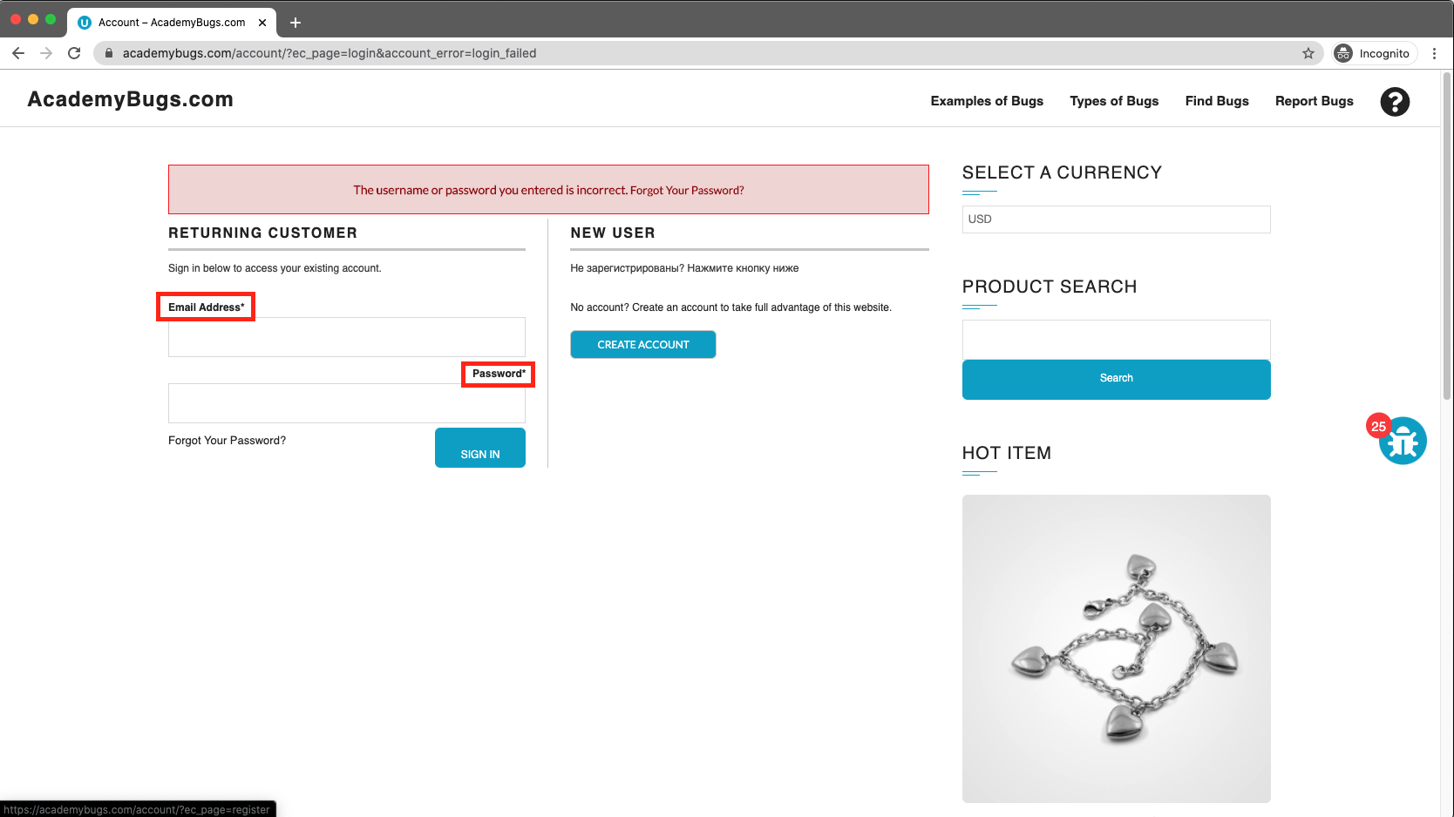

**Bug 23 (Performance):**

|  |  |  |  |
| --- | --- | --- | --- |
| **Title** | The My Space share page loads infinitely. | | |
| **Name of QA:** | Muhammad Hamas Khalid | | |
| **Severity** | **Issue Type** | **Frequency** | **Environment** |
| Low | Performance | Every Time | All Browsers |
| **Step to reproduce:**   1. Open [**https://academybugs.com**](https://academybugs.com/) 2. Click the Find Bugs link on the navigation bar 3. Open a product 4. Click the My Space share link | | | |
| **Expected Result:** | The user is able to share the product through My Space | | |
| **Actual result** | My Space share page loads infinitely | | |

**Attachments:**

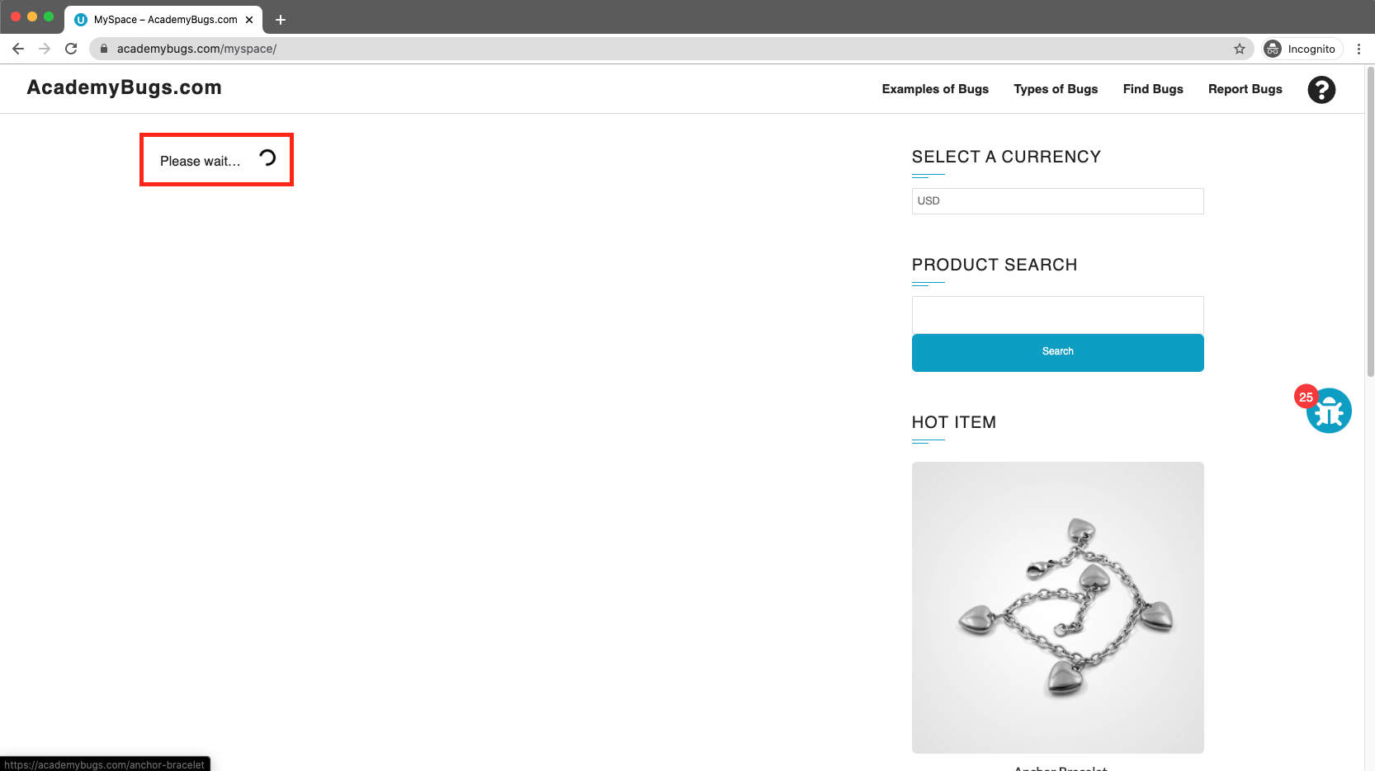

**Bug 24 (Crash):**

|  |  |  |  |
| --- | --- | --- | --- |
| **Title** | The page freezes when increasing the product quantity having green or pink colors chosen. | | |
| **Name of QA:** | Muhammad Hamas Khalid | | |
| **Severity** | **Issue Type** | **Frequency** | **Environment** |
| High | Crash | Every Time | All Browsers |
| **Step to reproduce:**   1. Open [**https://academybugs.com**](https://academybugs.com/) 2. Click the Find Bugs link on the navigation bar 3. Open a product that has color options 4. Choose the pink or green color 5. Increase the product quantity by 1 or more | | | |
| **Expected Result:** | The quantity is increased to a desired value | | |
| **Actual result** | The page becomes unresponsive when increasing the quantity with the pink or green colors chosen | | |

**Attachments:**

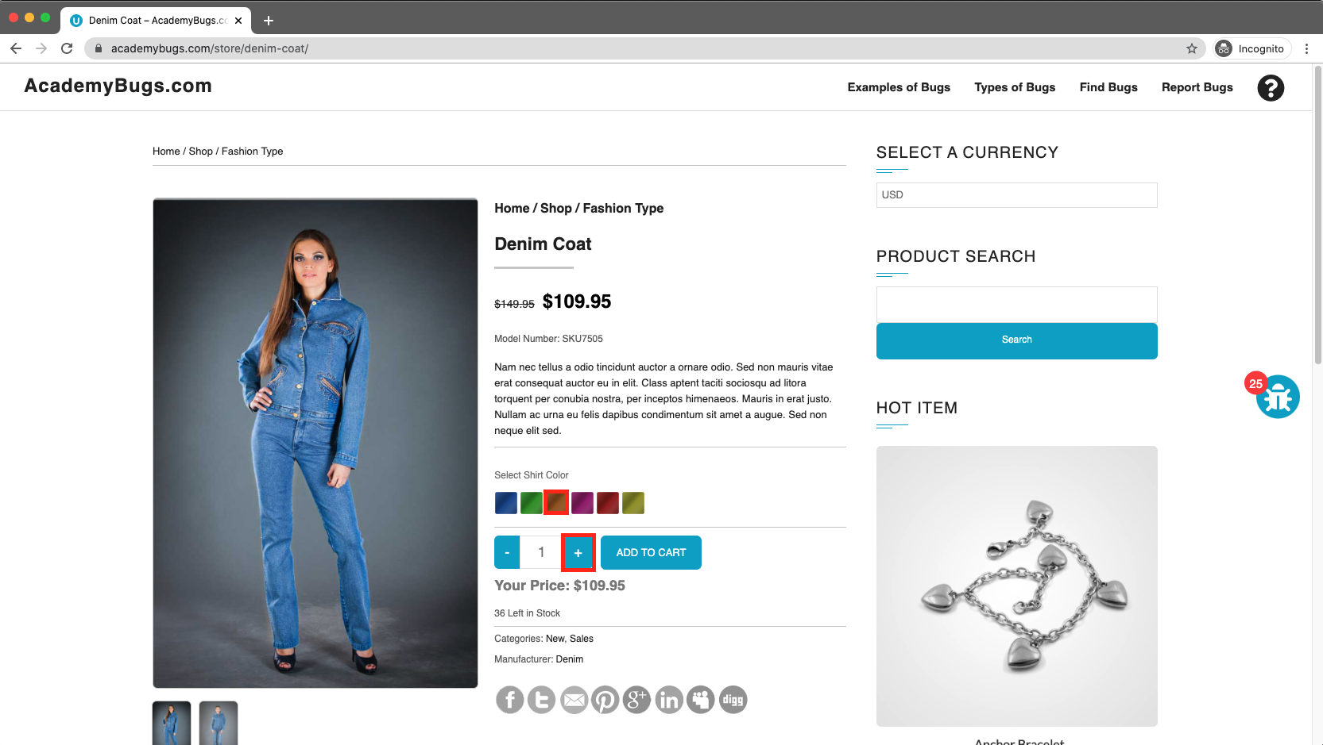

**Bug 25 (Visual):**

|  |  |  |  |
| --- | --- | --- | --- |
| **Title** | The image is not completely displayed. | | |
| **Name of QA:** | Muhammad Hamas Khalid | | |
| **Severity** | **Issue Type** | **Frequency** | **Environment** |
| Medium | Visual | Every Time | All Browsers |
| **Step to reproduce:**   1. Open [**https://academybugs.com**](https://academybugs.com/) 2. Click the Find Bugs link on the navigation bar 3. Click on "Dark Grey Jeans" | | | |
| **Expected Result:** | The product image fills the box entirely | | |
| **Actual result** | The image has a white space on the right | | |

**Attachments:**

